
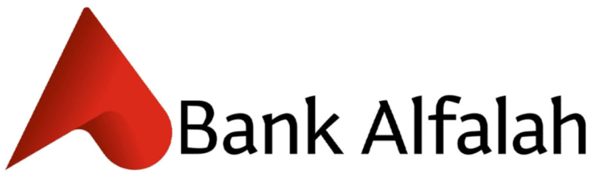
PIONEER SERVICES

Bank Al-Falah Limited

Operation Maintenance Proposal
HVAC System (Year 2023 – 2024)

CONTRACTOR:

Pioneer Services
2-C, Sunset Lane 1, Phase II, Ext. D.H.A,
Karachi.
Tel: 021-35881523
E. Mail: pioneer4us@gmail.com

CLIENT:

M/S Bank Al Falah Limited
B.A. Building, I.I. Chundrigar
Road Karachi
32414030-10; UAN: 111 777
786. Fax: 32461275

TERMS & CONDITIONS

Preventive maintenance will be performed as follows:

- Daily
- Weekly.
- Monthly.
- Quarterly.
- Semi Annual
- Annual.

Daily Operation Timings

- Morning shift: 07:00 Hrs to 16:00 Hrs
- Evening Shift: 15:00 Hrs to 23:00 Hrs

Staff (Morning)

- Operation Maintenance Incharge 01 Person
- Associate Engineer 01 Person
- AC Technician 01 Person
- Senior Electrician 01 Person

Staff (Evening)

1. AC Technician 01 Person
2. Electrician 01 Person
3. General Fitter 01 Person
4. Handy man 01 Person

MONTHLY OPERATION & MAINTENANCE CHARGES

Total Amount | 585,000
Add SST 13% | 76,050
Grand Total Amount | 661,050

Terms & Conditions

- Prices are inclusive of Sind services Tax.
- The Prices are Valid for only 01 Year Contract period and new contract will be made one month before the expiry of the previous contract.
- Replacement / repairing of any part / components will be charged extra.
- Supply of any part or material is not included in contract.
- The cost of transportation normally charges as per actual.
- Payment for the contract will be made against the bill on monthly basis.
- If any change in Govt. taxes will be charge accordingly.

M/S PIONEER SERVICES M/S BANK AL-FALAH
(CONTRACTOR) (CLIENT)

__________________ ________________

